University at Buffalo Department of Orthopaedics
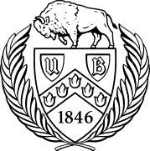
RESEARCH NEWSLETTER

Volume 7, January 2018

June A. and Eugene R. Mindell, MD Professor and Chair: Leslie J. Bisson, MD

Director of Clinical Research: John Leddy, MD

Director, Kenneth A Krackow Orthopedic Research Lab: Mark Ehrensberger, PhD

Editors: Melissa Kluczynski, MS; Sonja Pavlesen, MD, MS; Laura Ryan, MPH

Introduction

This is the third year of the Clinical Research Newsletter and a lot has hap-pened in the past year within the Clinical Research arm of UBMD Orthopae-dics and Sports Medicine. Between BGMC, ECMC, Oishei Children’s Hos-pital, Sports Medicine and the Concussion program, the department saw 22 studies completed (to abstract or publication status) and there are 37 ongoing projects, 14 of which involve the Orthopaedic residents. Members of the fac-ulty serve as journal reviewers (> 30 different journals) as well as journal editors, national meeting panelists, and on grant review committees. In the last academic year, there have been 45 publications in the peer-reviewed lit-erature, 31 poster presentations, and over 35 invited presentations at national

and international meetings. The department is collaborating with 9 UB and local departments, numerous national departments, and international universities. Resi-dents in the department have won national awards (2). The Concussion program is in the second year of a 5-year RO1 from the NIH to study the physiology of concussion

Inside this issue
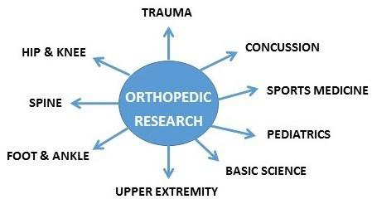

Introduction…………………….1

and was awarded a large foundation grant to run a national multicenter trial of exer-cise for concussion treatment. Under the leadership of Dr. Bisson, UB is a key par-ticipant in a Harvard-led NIH national multicenter randomized trial to investigate the optimal medical therapy for meniscal problems in the arthritic knee, which will get started very soon. We are also collaborating with other departments on internal multi -departmental projects to gather pilot data for external grant applications. Last year we implemented a new mentoring system to help first year residents identify a mean-ingful and reasonable research idea early on that is already having a significant im-pact.

Central Study Registration.…..2

Research Funding………….2-3

Funding Opportunities………..3

Recent Publications………...4-6

Recent Presentations………6-7

Epidemiology Corner………....8

I’d like to thank our Clinical Research Associates (CRAs) Melissa Kluczynski, MS (Sports Medicine), Sonja Pavlesen, MD, MS (BGMC, ECMC, and Oishei Children’s Hospital), and Mary Bayers-Thering, MS, MBA (BGMC, ECMC, Industry) for their incredible work ethic in helping the residents and the department attendings design and complete their projects, bringing them to fruition in the form of publications, presentations and grant applications. They are ably aided by Research Assistants Laura Ryan, MPH, Kathleen Lafferty, and a new addition to the team, Catherine Miller, MA. Working with Dr. Anders and the residents, Laura continues to improve the fracture database at ECMC and now we have outcomes data from the Department of Surgery to add to it. We have continued to enjoy excellent statistical consultation, led by Dr. Jiwei Zhao of the Department of Biostatistics. We continue to work with industry collabora-tors such as Carestream (weight bearing portable 3D CT scanner) to provide opportunities for groundbreaking research and resources to support our research mission.

(con’t on page 2)

1

Introduction letter Continued from Page 1:

We thank our chairman, Dr. Bisson, for providing the vision and leadership to move clinical research forward and for providing the resources to help ensure that UBMD Orthopaedics & Sports Medicine will be renowned internationally for its clinical care and research, each of which informs and improves the other. One of our goals is to take some of the exciting projects that are underway and fashion them into grant applications to foundations and federal agencies. Finally, our success depends upon your ideas and passion to improve clinical care through the vehicle of good clinical research, and we are here to help. If you have ide-as that will lead to a paper or a grant application for your work, please do not hesitate to contact me or the CRAs. Thank you for supporting Clinical Research at UBMD Orthopaedics & Sports Medicine.

Dr. John Leddy

Director of Clinical Research Department of Orthopaedics

Jacobs School of Medicine and Biomedical Sciences

University at Buffalo

UB Clinical and Translational Science Institute News

Central Study Registration (CSR) and Department Scientific Review

are mandatory as of November 13, 2017 for all UB clinical research!

The website for Central Study Registration is https://www.research.buffalo.edu/studyregistration.

Central Study Registration will be required prior to submitting your study to the IRB!

Please note: Department of Orthopaedics has established scientific review protocol including mandatory Pre-

study Abstract completion, Research Committee review and Department of Orthopaedics Research Committee
Study Approval letter.

Recent Research Funding

Dyskin E, Cole P (Co-PI: Duquin TR). North America Scapula Consortium (NASCon)- multi-center injury specific out-

comes registry. $6,500. Effective Dates: 12/2017-12/2021.

Ehrensberger MT. Mircomotion of Hybrid Glenoid Components. Foundation for Orthopaedic Research and Continu-ing Education ($76,081 total costs). Effective dates 7/1/2017-7/1/2018

Ehrensberger MT. (Co-Is: Campagnari AA, Titus A, Duquin TR). An Electrochemical Sense and Respond Osseointe-

grated Prosthesis, Phase 2. Office of Naval Research ($631,974 total costs). Effective Dates: 9/1/17-8/30/18.

Ehrensberger MT. (Co-I: Furlani EP). Computational Modeling and Experimental Validation of Cathodic Voltage-Controlled Electrical Stimulation Effects on Adjacent Microenvironment. UB Center for Advanced Biomedical and Bioengineering Technology ($131,000 total costs). Effective dates: 9/1/2017-6/30/2018.

Ehrensberger MT, Furlani EP (Co-PIs). Advancing the Science of Electrical Stimulation Therapy, Phase 2. Garwood Medical Devices ($40,000 total costs). Effective dates: 9/1/2017-8/31/2018.

2

Recent Research Funding (con’t)

Jornet JM (Co-Is: Feng L, Furlani EP, Gan Q, Sun Z, Wu Y, Ehrensberger MT). PFI: BIC: WearNet: Smart Health Moni-toring & Diagnosis System based on Wearable Nano-biosensing Networks. National Science Foundation ($1M total costs). Effective dates 9/1/2017-8/31/2020

Katz PI (Harvard University). (Co-PI: Leddy, JJ). NIH. NIAMS UO1 Grant. “Treatment of Meniscal Problems in Osteo-arthritis”. University at Buffalo Site PI.

Kirkwood K (Co-PI: Anders MJ). Metabolic Reprogramming of Myeloid-derived suppressor cells in post-traumatic osteoarthritis. Department of Defence- PR170673; $200,000. Effective Dates 12/2017-7/2019.

Leddy, J. 3/18-3/2020. American Medical Society of Sports Medicine (AMSSM) Collaborative Research Network (CRN)- Multicenter trial. “Sub-symptom aerobic exercise therapy to improve recovery from acute sport-related con-

cussion: A randomized controlled trial”. $300,000.

Marzo, J. Carestream Health: Weight bearing cone beam CT scan versus gravity stress radiography for analysis of supination external rotation injuries of the ankle $81,220

Marzo, J. Carestream Health: Measurement of tibial tuberosity-trochlear groove offset distance by weight bearing cone beam CT scan $47,250

Marzo, J. Ralph C. Wilson Jr Foundation Legacy Grant: The Ralph and Mary Wilson Visiting Professorship, Sports Medicine Surgical Outcomes Initiative, Sports Medicine Instruction Laboratory, Translational Research $160,000

Funding Opportunities

Feb 8– American Shoulder and Elbow Surgeons— Research Grant

Feb 9- American Medical Society for Sports Medicine—Clinical Research Grant
Feb 12– North America Spine Society (Ltr of Proposal; Grant (by invitation only due May 14)
Feb 13– Patient Centered Outcome Research Opportunities— Various Grants Available (Letter of In-tent)
March 1– The American Orthopaedic Society for Sports Medicine— Kirkley Clinical Outcomes Grant April 2– American Society for Surgery of the Hand— Basic & Clinical Science Grants
May 25– National Institute of Arthritis and Musculoskeletal and Skin Diseases– Various Grants Availa-
ble
May TBD– Orthopaedic Research and Education Foundation– Resident Research Grant July 16– Orthopaedic Research Society— Collaborative Exchange Grant

3

Recent Publications

Congratulations to all authors!

Peer-Reviewed Articles:

Bisson, L.J., Kluczynski, M.A., Wind, W.M., Fineberg, M.S., Bernas, G.A., Rauh, M.A., Marzo, J.M., Zhou, Z., Zhao, Z. How Does the Presence of Chondral Lesions Affect Patient Outcomes after Partial Meniscectomy?: The Chondral Lesions and Meniscus Procedures (ChAMP) Randomized Controlled Trial. American Journal of Sports Medicine. 2017 Dec 1:363546517744212. doi: 10.1177/0363546517744212.

Bisson, LJ, Kluczynski, MA, Wind, WM, Fineberg, MS, Bernas, GA, Rauh, MA, Marzo, JM, Zhou, Z, Zhao, Z. Patient-reported outcomes of debridement versus observation of chondral lesions found

during partial meniscectomy: The Chondral Lesions and Meniscus Procedures (ChAMP) Randomized
Controlled Trial. Journal of Bone and Joint Surgery; 2017 Jul 5;99(13): 1078-85.

Boyle KK, Duquin TR. Prevention of Surgical Site Infection and Anitbiotic Prophylaxis in Shoulder and Elbow Surgery.

Othopaedic Clinics of North America. November 2017.

Boyle KK, Nodzo SR, Pavlesen S, Ritter CA. (in press). Tranexamic Acid Reduces Perioperative Blood Loss and Hemarthrosis in Total Ankle Arthroplasty. American Journal of Orthopaedics. 2017.

Boyle KK, Nodzo SR, Ferraro JT, Augenblick DJ, Pavlesen S, Phillips MJ. Uncemented versus Cemented Cruciate Re-training Total Knee Arthroplasty in Patient with a Body Mass Index over 30. J Arthroplasty 2017. Dec 1. pii: S0883-5403(17)31048-3. doi: 10.1016/j.arth.2017.11.043

Brooks EK, Ehrensberger MT. “Bio-Corrosion of Magnesium Alloys for Orthopaedic Applications” Journal of Function-al Biomaterials, 2017 Sep 1;8(3). pii: E38

Brown, MJ, Matthews, JR, Bayers-Thering, MT, Phillips, MJ, Krackow, KA. Low Incidence of Postoperative Complica-tions With Navigated Total Knee Arthroplasty. J Arthroplasty; 2017 Jul;32(7):2120-2126

Browning, W, Kluczynski, MA, Curatolo, C, Marzo, JM. Suspensory versus aperture fixation of

quadrupled hamstring tendon autograft in anterior cruciate ligament reconstruction: a meta-analysis. American Journal of Sports Medicine; 2017 Aug;45(10):2418-2427.

Gabbett, TJ, Kearney, S, Bisson, LJ, Collins, J, Sikka, R, Winder, N, Sedgwick, C, Hollis, E, Bettle, JM. Seven tips for de-veloping and maintaining a high performance sports medicine team. British Journal of Sports Medicine. 2017 Sep 27. pii: bjsports-2017-098426. doi: 10.1136/bjsports-2017-098426.

Haider, M.N., Leddy, J.J., Pavlesen, S., Kluczynski, M.A., Baker, J.G., Miecznikowski, J.C., Willer, B.S. (in press). A Sys-

tematic Review of Criteria used to Define Recovery from Sport-Related Concussion in Youth Athletes. British Journal of Sports Medicine. 2017 Jul 22. pii: bjsports-2016-096551. doi: 10.1136/ bjsports-2016-096551

Haider MN, Leddy J, Baker JG, Kiel JM, Tiso M, Ziermann KA, and Willer B. (in press). Effect of Specialized Concussion Management Training among Residents and Medical Students. Concussion.

Kluczynski, M.A., Marzo, J.M., Wind, W.M., Fineberg, M.S., Bernas, G.A., Rauh, M.A., Zhou,

Z., Zhao, Z., Bisson, L.J. The Effect of Body Mass Index on Clinical Outcomes in Patients Without Radiographic Evi-dence of Degenerative Joint Disease After Arthroscopic Partial Meniscectomy. Arthroscopy, 2017 Nov; 33(11): 2054-2063.

4

Recent Publications (con’t)

Lawlor, M.C., Kluczynski, M.A., Marzo, J.M. (in press). Weightbearing cone beam CT scan reveals the state of stability of supination external rotation ankle fractures in a cadaver model. Foot and Ankle International.

Makki AY, Leddy J, Takano K, and Jain R. (2017). An Unusual Cause of Headache and Fatigue in a Division 1 Collegiate Athlete. Clinical Journal of Sports Medicine. 2017 Jul; 27(4):e58-59.

MARS Group (Rauh, M.) Risk Factors and Predictors of Significant Chondral Surface Change from Primary to Revision ACL Reconstruction: A MOON and MARS Cohort Study. American Journal of Sports Medicine. 2017 Dec 1. PMID: 29244532

MARS Group (Rauh, M.). Surgical Predictors of Clinical Outcomes after Revision ACL Reconstruction.

American Journal of Sports Medicine . 2017 Sept; 45(11): 2586-2594. PMID: 28696164

MARS Group (Rauh, M.). Subsequent Surgery After Revision ACL Reconstruction: Rates and Risk Factors From a

Multicenter Cohort. American Journal of Sports Medicine. 2017 Jul 45(9): 2068-2076. PMID: 28557557

Martin EJ, Duquin TR, Ehrensberger MT. Reverse total shoulder glenoid baseplate stability

with superior glenoid bone loss. Journal of Shoulder and Elbow Surgery. 2017 Oct;26(10):1748-1755. doi: 10.1016/ j.jse.2017.04.020. Epub 2017 Jul 6.

Marzo, J. Comparison of a novel weight bearing cone beam computed tomography (CT) scanner versus a conventional CT scanner. (2017). Physical Medicine and Rehabilitation Research, 1(5): 1-3.

Marzo, J, Kluczynski, M, Notino, A, Bisson, L. Measurement of tibial tuberosity-trochlear groove offset distance by weight bearing cone beam CT scan. Orthopaedic Journal of Sports Medicine. 2017 Oct 19; 5(10) 1-5.

Marzo JM, Kluczynski MA, Clyde C, Anders MJ, Mutty CA, Ritter CA. Weight bearing cone beam CT scan versus gravi-ty stress radiography for analysis of supination external rotation injuries of the ankle. Quant Imaging Med Surg 2017 Dec; 7(6): 678-684. doi: 10.21037/qims.2017.12.02.

McCrory P, Meeuwisse W, Dvorak et al. Infographic: Consensus statement on concussion in sport. Br J Sports Med.

2017 Sep 12. pii: bjsports-2017-098065. doi: 10.1136/bjsports-2017-098065.

Nodzo SR, Boyle KK, Bhimani S, Duquin TR, Miller AO, Westrich GH. Propionibacterium acnes

Host Inflammatory Response During Periprosthetic Infection is Joint Specific. Hospital for Special Surgery Journal. 2017 Jul; 13: 159-164.

Nodzo, SR, Boyle KK, Nocon AA, Miller A, Westrich GH. (in press). Success Rates, Characteristics, and

Costs of Articulating Antibiotic Spacer for Total Knee Periprosthetic Joint Infection. The Knee. Oct;24(5):1175-1181.
doi: 10.1016/j.knee.2017.05.016.

Nodzo, S.R., Pavlesen, S., Boyle, K., Rachala, S. rhBMP-2 Use is Effective in Revision Total Hip Arthroplasty with Ace-tabular Defects. International Orthopaedics. 2017 Nov 3. doi: 10.1007/s00264-017-3671-3.

Trojian TH, Wang D, and Leddy JJ. Nutritional Supplements for Concussions. Current Sports Medicine Reports. 2017 July/August; 16(4):247-255.

5

Recent Presentations

Posters:

Kluczynski, M.A., Marzo, J.M., Wind, W.M., Fineberg, M.S., Bernas, G.A., Rauh, M.A., Zhou,

Z., Zhao, Z., Bisson, L.J. (July 2017). The Effect of Body Mass Index on Clinical Outcomes after Arthroscopic Partial Meniscectomy. Poster presented at the Orthopaedic Research Society Upstate New York and Northeast Regional Symposium at the University of Rochester, Rochester, NY.

Leddy, JJ. Headway of WNY. Museum of disAbility. “Concussion”. Buffalo, NY. Nov. 29, 2017.

Marzo, J. Failed Glenohumeral Instability and Bone Defects SUNY University at Buffalo Department of Orthopedic

Surgery Sports Medicine Rounds, Oct 3, 2017.

Marzo, J. Graft choice for ACL reconstruction in 2017 National Athletic Trainers Association Symposium on Sideline Management of the Athlete August 11, 2017 Buffalo New York.

Marzo, J. Liability of the Sports Team Provider, University at Buffalo Law School Oct 4, 2017.

Marzo, J.M., Kluczynski, M.A., Notino, A., Bisson, L.J. (July 2017). Measurement of Tibial Tuberosity-Trochlear Groove Offset Distance by Weight Bearing Cone Beam CT Scan. Poster presented at the Orthopaedic Research Society Up-state New York and Northeast Regional Symposium at the University of Rochester, Rochester, NY.

Pavlesen, S., Kluczynski, M., Bisson, L.J., Marzo, J.M. (July 2017). Is Body Mass Index Associated with Outcomes of Arthroscopic Knee Surgery?: An Updated Systematic Review. Poster presented at the Orthopaedic Research Society

Upstate New York and Northeast Regional Symposium at the University of Rochester, Rochester, NY.

Ryan, L., Pavlesen, S., Anders, M. Long Bone Fractures Database in Adult Population of Western New York. Ortho-paedic Research Society Upstate New York and Northeast Regional/7th Annual CMSR Symposium. University of Rochester, Rochester, NY, July 2017.

Touban, B., Pavlesen, S., Smoak, J., Sayegh, J.B.S., Shen, X., Zhao, J., Anders, M." Association of Sarcopenia with 1 year all Cause Mortality in Elderly Orthopaedic Trauma Patient". Orthopaedic Trauma Association (OTA) Annual Meeting, Vancouver, BC. October 11-14, 2017.

Invited Talks:

Bernas, G. To Debride or Not To Debride Cartilage Lesions at the Time of Arthroscopic Meniscectomy? Results of the

ChAMP Trial. 56th Annual Meeting, University of Michigan Department of Orthopaedic Surgery, Carl E. Badgley Lec-
tureship Sports Medicine/Shoulder Surgery, Ann Arbor, Michigan September 15, 2017.

Ehrensberger, M. An Electrochemical Sense and Respond Osseointegrated Prosthesis, Monitoring Osseointegrated Prostheses Program Meeting, Office of Naval Research (7/2017)

6

Recent Presentations (continued)

Ehrensberger, M. Cathodic Voltage-Controlled Electrical Stimulation for Orthopedic Infection Control, Invited Key-note Presentation, WELISA (Analysis and Simulation of Electrical Interactions of Implants with Bio-systems) Research Training Group Symposium, Rostock University, Rostock-Warnemunde, Germany (7/2017)

Leddy JJ. “Active Recovery from Concussion and PPCS”. Big Ten - Ivy League TBI Summit. Chicago, IL. July 19-20, 2017.

Leddy JJ. “Cervicocephalic Syndrome: What Every Physiatrist Should Know”. American Congress of Rehabilitation Medicine Annual Meeting. October 27, 2017. Atlanta, GA.

Leddy JJ. “Early Physical Activity and Recovery from Concussion.” MARC (ACSM) Annual Conference. November 3,

2017. Harrisburg, PA.

Leddy JJ. “Effective Exercise Regimens Available Post-Concussion 2017”. Ice Hockey Summit III: Action on Concus-sion. Mayo Clinic. Rochester, MN. September 28-29, 2017.

Leddy JJ. “Return to Learn”. HCAMP Concussion Summit. Honolulu, HI. July 15, 2107.

Leddy JJ. “Return to Learn After Concussion”. Gannon University. Erie, PA. September 12, 2017.

Leddy JJ. “Return to Learn: Strategies to Facilitate Successful Reintegration in School for students with Concussion”.

Speech Language Pathology. John Burns School of Medicine. Honolulu, HI. July 13, 2107.

Leddy JJ. “Should we rest athletes after concussion?”. National Neurotrauma Society Meeting. Snowbird, Utah. July

9, 2017.

Leddy JJ. “Sport & The Buffalo Concussion Treadmill Test.” BRAINSTORM Conference. Skype video presentation. Hawke’s Bay, New Zealand. November 17, 2017

Leddy JJ. “The Buffalo Concussion Treadmill Protocol: Early Return to Activity”. HCAMP Concussion Summit. Honolu-lu, HI. July 15, 2107.

Leddy JJ. “The Clinical Evaluation of Concussion: Update from Berlin”. Queen’s Medical Center Department of Inter-nal Medicine Grand Rounds. Honolulu, HI. July 14, 2107.

Leddy JJ. “The Physiology of concussion”. American Congress of Rehabilitation Medicine Annual Meeting. October

28, 2017. Atlanta, GA.

Leddy JJ. “Translating Science in to Practice: Evidence Based Assessment and Treatment of Concussion”. Internation-al Pediatric Brain Injury Society. Rome, Italy. September 22, 2017.

7

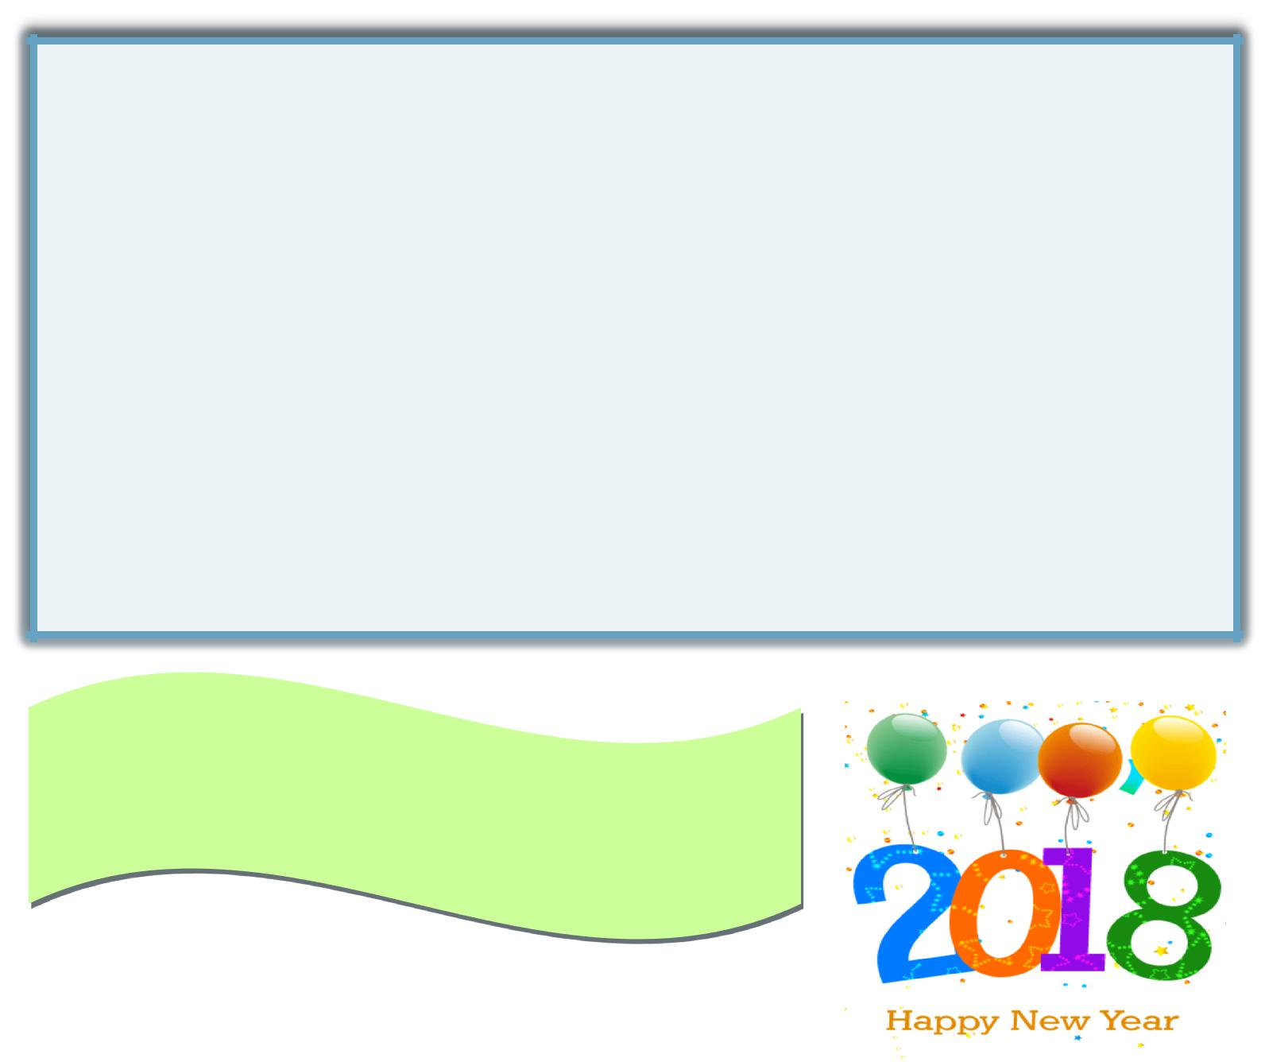
Epidemiology Corner: Systematic Reviews and Meta-Analyses

Systematic Review: A high-level summary of primary research on a specific research question that attempts to identify , select, synthesize, and appraise ALL high-quality evidence relevant to the study question

Meta-Analysis: Typically begins with a systematic review of the literature and uses statistical methods to quantitatively evaluate pooled data from single studies.

What is the difference between the two?: Systematic reviews are a qualitative summary of the available evidence and meta-analyses are a quantitative summary of the available evidence. Meta-analyses may not include ALL relevant studies due to available data for analysis (unlike a systematic review).

Our department now has access to Comprehensive Meta-Analysis software to facilitate meta-analyses.

Please contact Melissa Kluczynski for more information (mk67@buffalo.edu, 716-204-3209).

Porta, M. A Dictionary of Epidemiology. Fifth Edition. 2008. Oxford.

Wishing you a happy & productive year !

—Research Team

Research Team Contact Information

Directors

John Leddy, MD, (leddy@buffalo.edu) Mark Ehrensberger, PhD (mte@buffalo.edu)

Director of Clinical Research Director of the Kenneth A. Krackow Orthopaedic Research Laboratory

Buffalo General Medical Center/ Oishei Children’s Hospital/ ECMC

Sonja Pavlesen, MD, MS (pavlesen@buffalo.edu) Mary Bayers-Thering, MS, MBA (MBayers-Thering@KaleidaHealth.Org)

Research Assistant Professor Research Coordinator, Coordinator for Surgical Skills Training

Laura Ryan, MPH (laurabec@buffalo.edu) Catherine Miller, BS, MA, LPCC, NBCC, QHP (cr55@buffalo.edu)

Research Assistant Research Assistant

Sports Medicine/Harlem Rd. office

Melissa Kluczynski, MS (mk67@buffalo.edu) Kathleen Lafferty (klaffert@buffalo.edu)

Clinical Research Associate Research Assistant, Administrative Assistant

8

